04/10/22 fundamentals of computing V.Tarak ram

192110545

13.Write a program for product series(factorial of a given number)?

Sol:

Program in c:

#include<iostream>

using namespace std;

int main()

{

int x=1,fact=1,n;

printf("enter a number to find factorial:");

scanf("%d",&n);

while(x<=n)

{

fact=fact*x;

x++;

}

printf("factorial of %d is:%d",n,fact);

return 0;

}

Program in raptor:

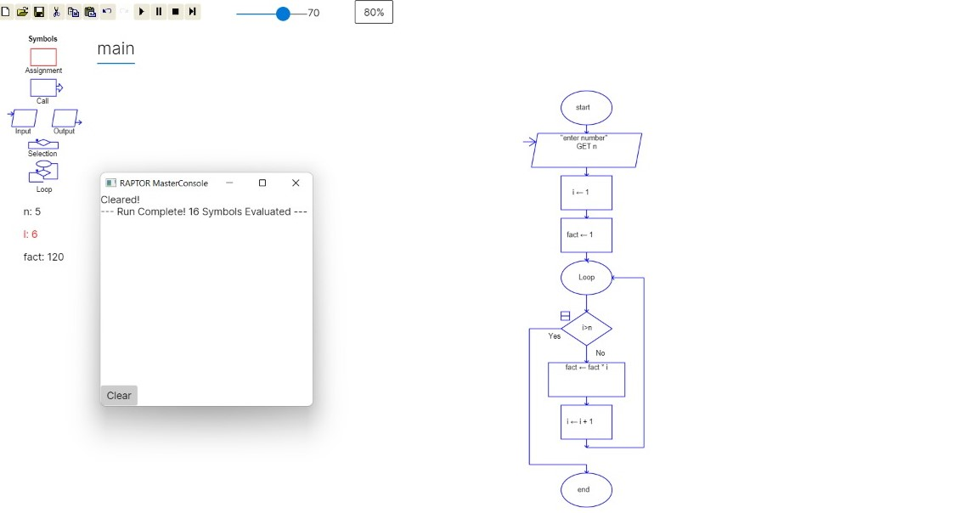

14.finding given numbers is Armstorng or not?

Sol:

Program in c:

#include<iostream>

using namespace std;

int main()

{

int n,r,sum=0,temp;

printf("enter the number:");

scanf("%d",&n);

temp=n;

while(n>0)

{

r=n%10;

sum=sum+(r*r*r);

n=n/10;

}

if(temp==sum)

printf("armstrong number");

else

printf("not an armstrong number");

return 0;

}

Program In raptor:

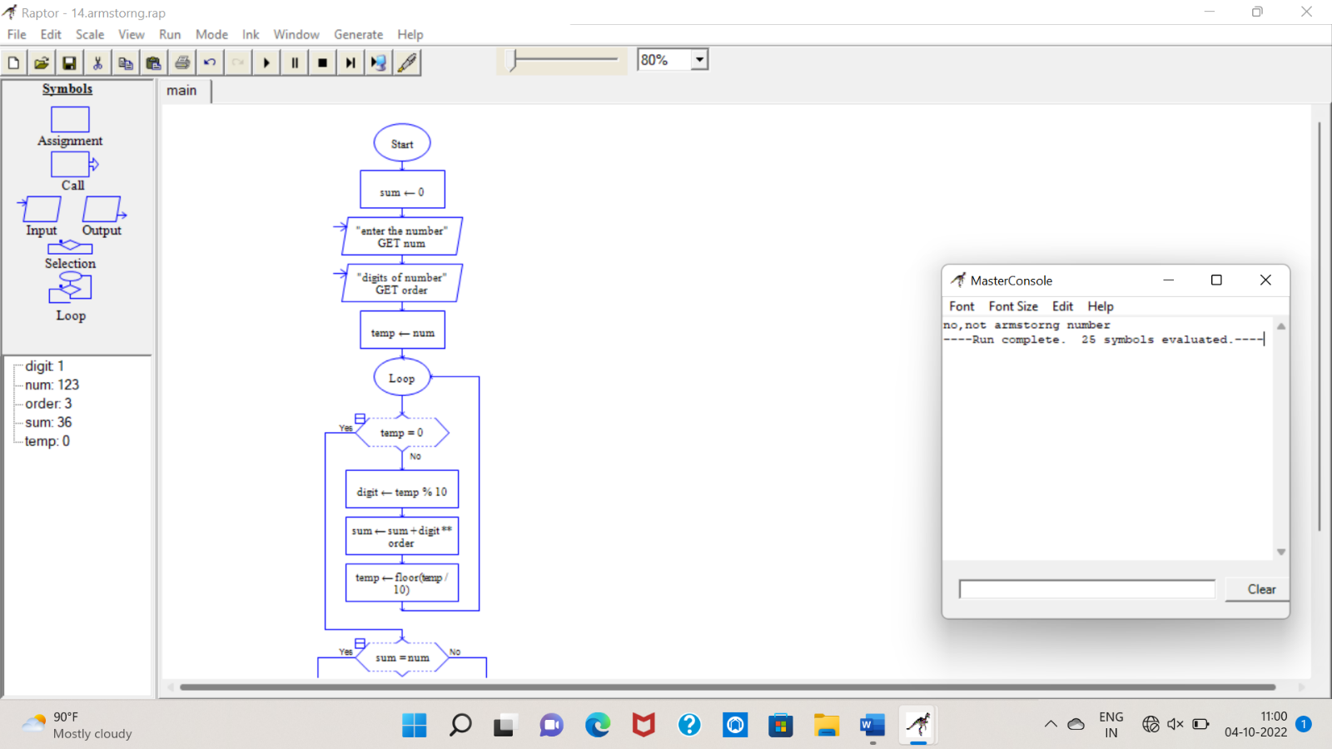

15.summing up any n numbers and finding average?

Sol:

Program in c:

#include<iostream>

using namespace std;

int main()

{

int num,sum = 0,n;

float avg;

printf("enter term of n number:");

scanf("%d",&n);

for(int i = 1; i <= n; i++)

{

printf("number %d = ",i);

scanf("%d",&num);

sum=sum + num;

}

avg = sum / n;

printf("the sum of n numbers = %d",sum);

printf("the average of n numbers = %.2f\n",avg);

}

Program in raptor:

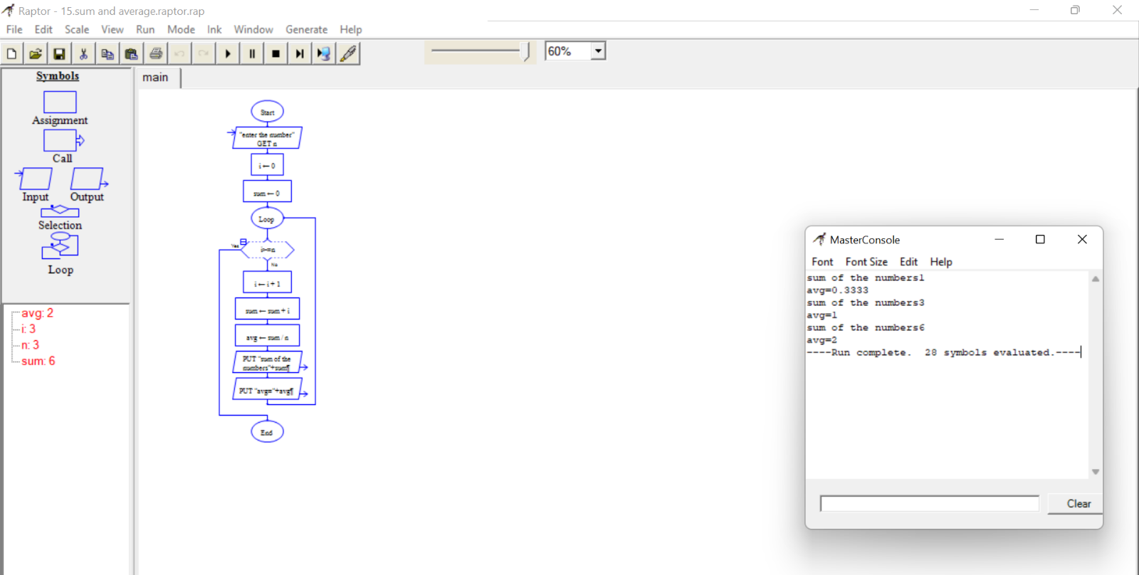

16.printing digits of an integer number?

Sol:

Program in c

#include<stdio.h>

int main()

{

int number;

printf("enter a number:");

scanf("%d",&number);

{

printf("you entered:%d",number);

}

return 0;

}

Program in raptor:

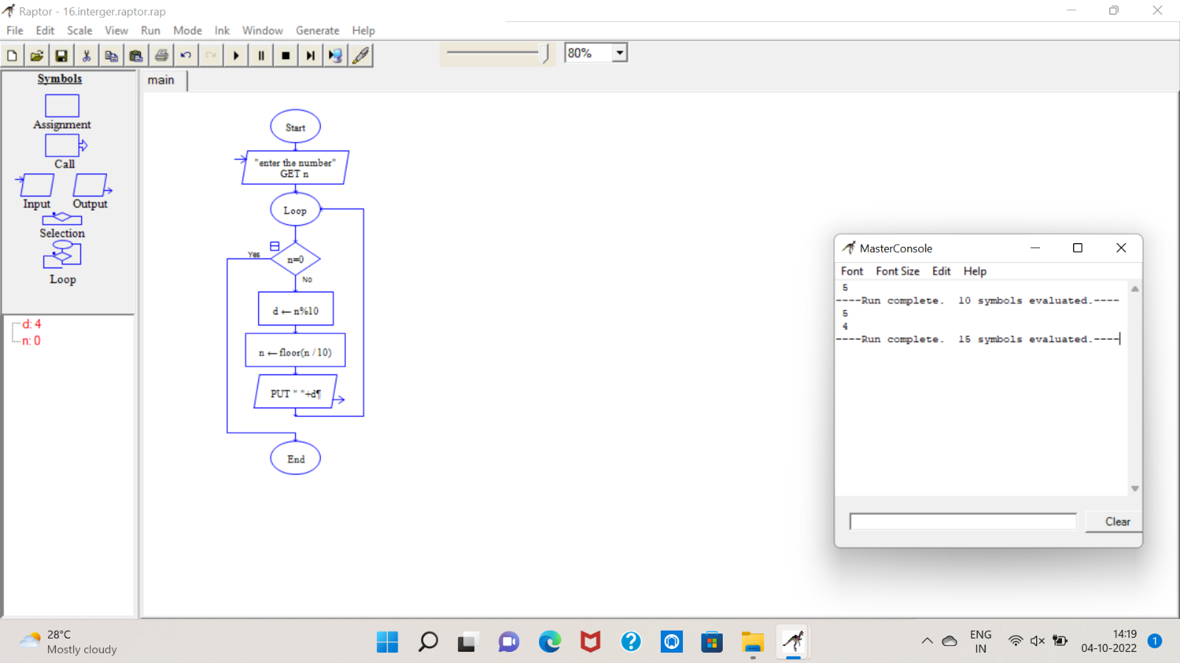

17.summing up the digits of an integer?

Sol:

Program in c:

#include<stdio.h>

int main ()

{

int num, sum = 0;

printf("enter a number:");

scanf("%d",&num);

while(num!=0){

sum += num % 10;

num = num / 10;

}

printf("Sum: %d\n",sum);

return 0;

}

Program in raptor:

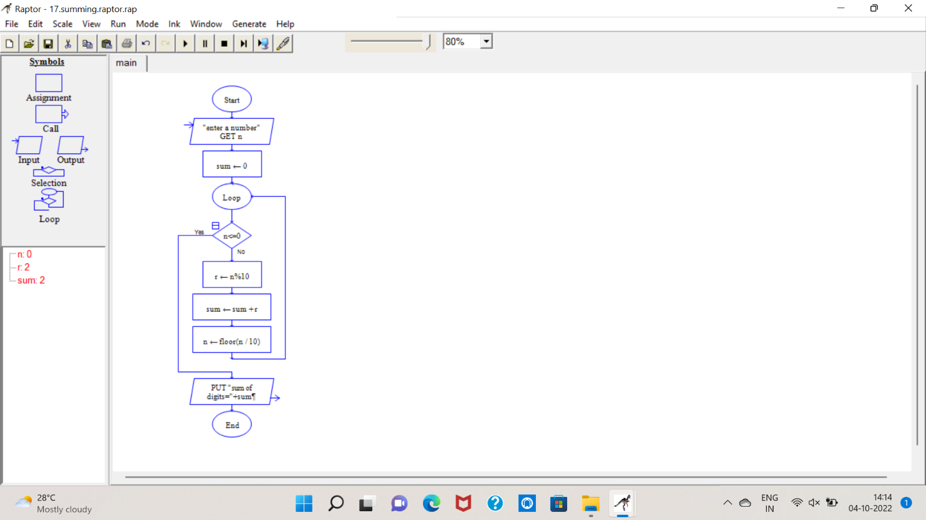

18.reversing the digits of an integer number?

Sol:

Program in c:

#include<stdio.h>

int main()

{

int n,reverse = 0,remainder;

printf("enter an integer:");

scanf("%d",&n);

while(n!=0)

{

remainder = n % 10;

reverse = reverse * 10 + remainder;

n /=10;

}

printf("reversed number = %d",reverse);

return 0;

}

Program in raptor:

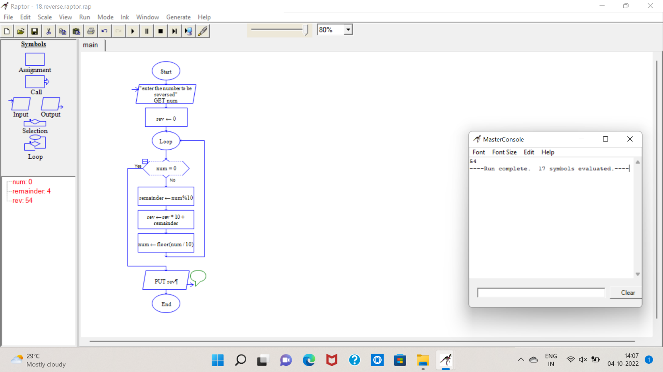

**19.finding the given integer is positive and negative?**

**Sol:**

**Program for c:**

**#include<stdio.h>**

**int main ()**

**{**

**int num;**

**printf("enter a number:");**

**scanf("%d",&num);**

**if (num>=1)**

**printf("%d is a positive integer",num);**

**else**

**printf("%d is a negative number",num);**

**return 0;**

**}**

**Program for raptor:**

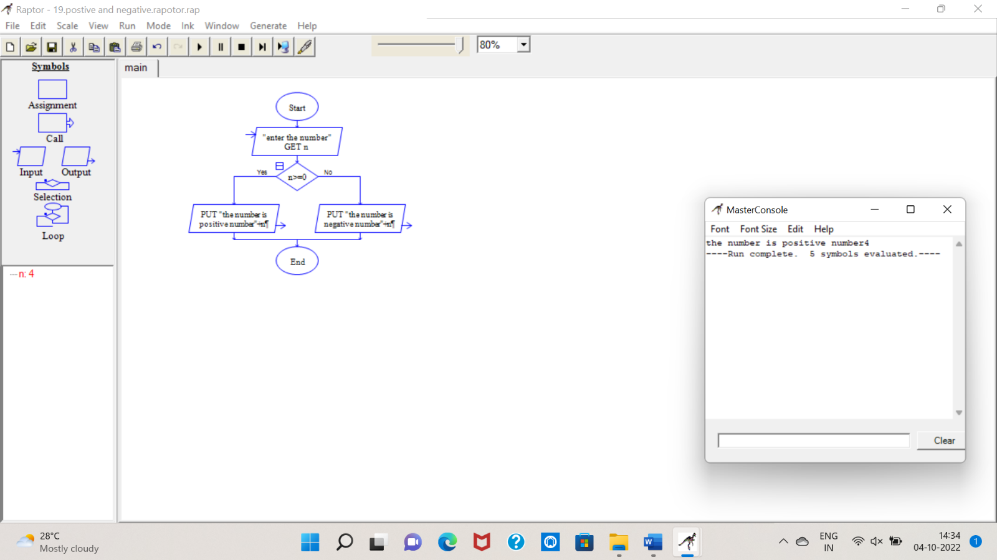

**20.swapping of two numbers with temporary variable?**

**Sol:**

**Program for c:**

**#include<stdio.h>**

**int main()**

**{**

**int a,b;**

**printf("enter a value:");**

**scanf("%d",&a);**

**printf("enter b value:");**

**scanf("%d",&b);**

**printf("Before swap a=%d b=%d",a,b);**

**a=a+b;**

**b=a-b;**

**a=a-b;**

**printf("\nAfter swap a=%d b=%d",a,b);**

**return 0;**

**}**

**Program for raptor:**

